Resare, Griselle Jane C.

BSIT3J

**GET**

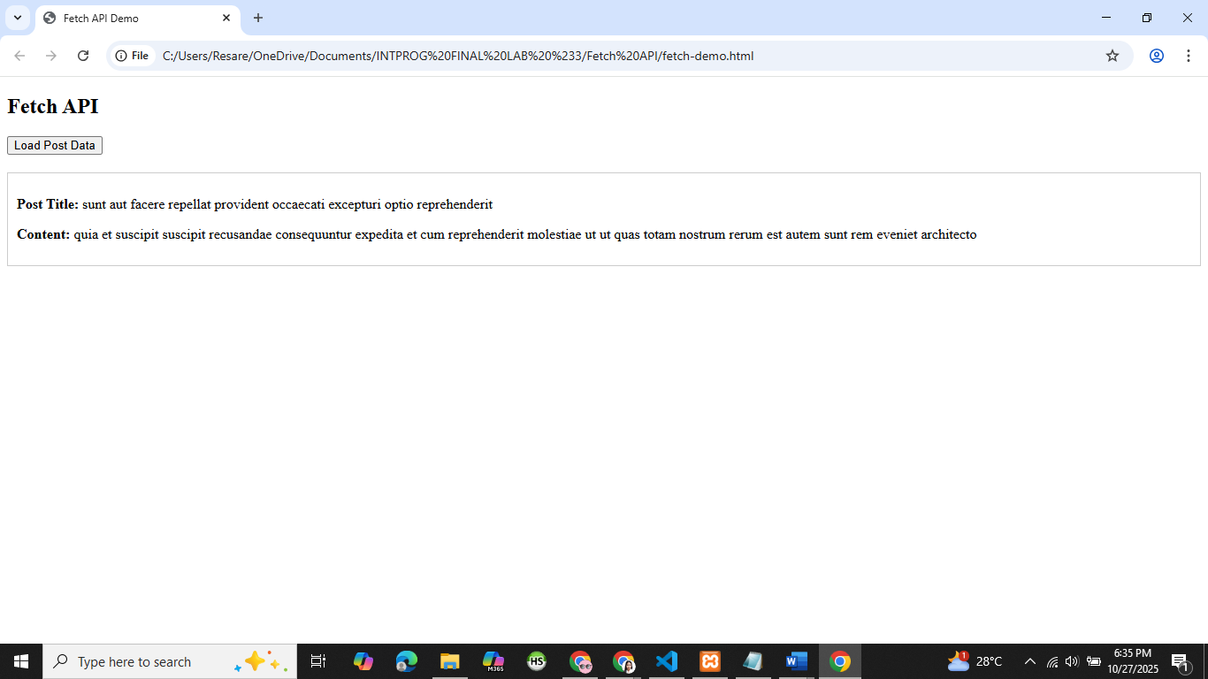

**POST**

